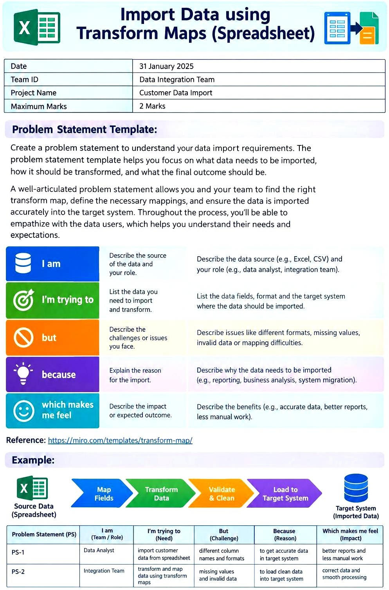
28 September 2026
SWTID-2026-2854
Topic Import Data using Transform Maps (Spreadsheet)

